**Tour to Song-Kul Lake for 3 days**

Country: **Kyrgyzstan**

Period: **June - September**

**Days: 3 / Nights: 2**

Organizing any complexity of tours to Issyk-Kul, Son-Kul, around Kyrgyzstan and Central Asia. We guarantee you high quality of service and individual approach!

Song-Kul Lake lies at an altitude of 3016 m, and has an area of about 270 km and volume of 2.64 km. Lake's maximum length is 29 km, breadth about 18 km, and extreme depth 13.2 m. It is the second largest lake after Issyk-Kul Lake and the largest fresh water lake in Kyrgyzstan. Its name, meaning "following lake", is popularly considered to refer to this relation. A broad summer pasture and then mountains surround it.

#### [Day 1: Bishkek - Burana - Song-Kul](https://concept.kg/en/tours/inbounds/14/#program_collapse_55)

In the morning meet a guide and driver and depart to Song-Kul Lake.   
On the way, visit the Burana Tower, a small nearby Museum and open air Balbals (stone figures). Visitors can climb to the top of the Minaret and enjoy the beautiful view of the valley.   
Stop in Kochkor village to have lunch.  
Upon arrival to Song-Kol, overnight at a yurt camp.

Meals: lunch, dinner

#### [Day 2: Song-Kul](https://concept.kg/en/tours/inbounds/14/#program_collapse_56)

Full-day free at Song-Kul Lake.  
Hiking and horseback riding is available upon request.  
Overnight at the yurt camp.

Meals: breakfast, lunch, dinner

#### [Day 3: Song-Kul - Bishkek](https://concept.kg/en/tours/inbounds/14/#program_collapse_57)

After the breakfast, departure from Song-Kul to Bishkek.  
End of services.

Meals: breakfast

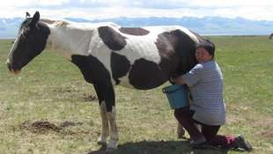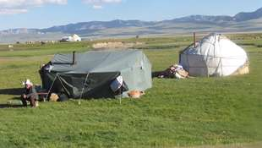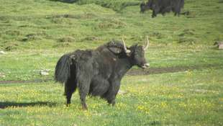

| **GROUP SIZE** | **PRICE IN USD/PER PERSON** |
| --- | --- |
| 6 | 410 USD |
| Supplementary pay for upgraded yurt (individual stay, beds) | 110 USD |

To find out prices for a group consisting of less/more than 6 people, please, contact us at: [info@travelscruiser.com](mailto:info@travelscruiser.com)

| **PRICE INCLUDES** |  |
| --- | --- |
| Accommodation | Song-Kul - yurt camp (2 nights) |
| *Side note:* | *Accommodation conditions at yurt camp are very traditional,  meaning that person will be able to share toilet outside of the yurt and be able to experience Kyrgyz rural lifestyle firsthand.  Usually 3-6 pax per yurt (during the high season) Single accommodation can be arranged if there is some vacant space* |
| Transport | Comfortable car with a/c (minivan) |
| Guide services (Eng/Russ) | Included |
| Meals | Meals mentioned in the program |
| Water | 1 liter/per person/per day |
| Entrance fees | According to the program |

| **PRICE EXCLUDES** |
| --- |
| International flights |
| Visa/letter of invitation to Kyrgyzstan |
| Early/late check-in/check-out |
| Meals not mentioned in the program |
| Personal expenses |
| Horseback riding |

**Contact information:**

[www.travelscruiser.com](http://www.travelscruiser.com)

Phone (24/7): +996 …………., +996 ……….

E-mail: [info@travelscruiser.com](mailto:info@travelscruiser.com)